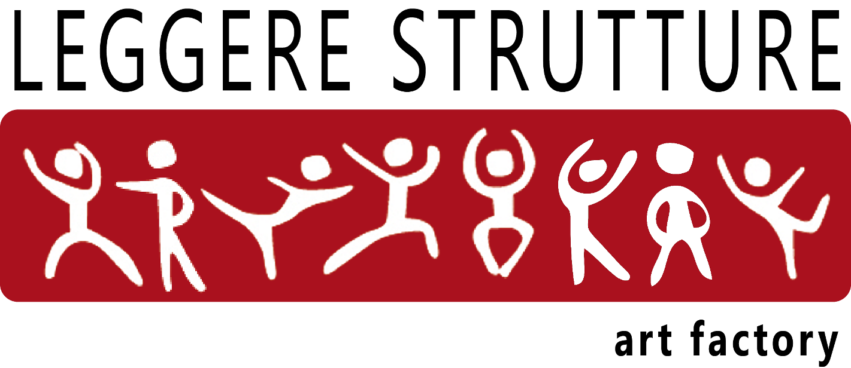

APPLICATION FORM
WORKSHOP “ULTIMA VEZ REPERTORY”
21 – 22 NOVEMBER 2015

Name........................................................................................................................................

Surname..................................................................................................................................

Age....................date of birth................................................male/female: ….....

nationality...................................................................state.......................................................

country…..............................................................................zip code.......................

address..............................................province..................................................num..............

ID/ passaport or other n°.......................... …...........................................................................

Email.............................................................................................

Workshop participation is limited

Registration by september 18
Workshop fee : 180€

Registration after september 18
Workshop Fee: 190€

*Registration to two workshops:
Brigel Gjoka Workshop on 11-12 december and Eduardo Torroja "Ultima Vez Repertory" on 21-22 november, fee: 340€

specify the chosen of day and time to the workshop :

.........................................................................................................................................

A deposit fee of 50€ by bank transfer to:
LEGGERE STRUTTURE ART FACTORY
Cassa di Risparmio di Cento
IBAN: IT 35 N 06115 36990 000000001162
CODE BIC / SWIFT: CRCEIT2C
attach a copy of the payment and application form to confirm your registration

For more info:
Leggere Strutture Art Factory
street Ferrarese 169/a, Bologna 40128, Italy
T. +39 051.0951158/59 – segreteria@leggerestrutture.it
www.leggerestrutture.it

